**T.R.**

**ÜSKÜDAR UNIVERSITY**



|  |
| --- |
| **FACULTY OF ENGINEERING AND NATURAL SCIENCES**  **ONLINE INTERNSHIP NOTEBOOK** |



**FACULTY OF ENGINEERING AND NATURAL SCIENCES**

Name Surname :Ömer Can Parlak

Department :Software Engineering

Grade :2

StudentNumber :180209004

InternshipSubject : Currency Exchange

Start Date :02/08/2021

FinishDate :29/08/2021

Summary of the Internship From 02/08/2021 Until 29/08/2021

|  |  |  |  |
| --- | --- | --- | --- |
| DATE | DAY | INTERNSHIPS | PageNo |
| 02/08/2021 | Monday | Introdution to Andiroid Studio | 1 |
| 03/08/2021 | Tuesday | How to describe to layout in Main Activty | 2 |
| 04/08/2021 | Wednesday | Off Day | 3 |
| 05/08/2021 | Thursday | To research how to make currency conversion in Android Studio | 4 |
| 06/08/2021 | Friday | Retrofit Cyripto Money | 5 |
|  |  |  |  |
| 09/08/2021 | Monday | Make a Layout for Currency Converter | 6 |
| 10/08/2021 | Tuesday | I Make MainActivty Code | 7 |
| 11/08/2021 | Wednesday | I Encountered An Error | 8 |
| 12/08/2021 | Thursday | New Solution | 9 |
| 13/08/2021 | Friday | Off Day | 10 |
|  |  |  |  |
| 16/08/2021 | Monday | Make a projct again | 11 |
| 17/08/2021 | Tuesday | Make ActivtyMain Body | 12 |
| 18/08/2021 | Wednesday | Make Button Method | 13 |
| 19/08/2021 | Thursday | Of Day | 14 |
| 20/08/2021 | Friday | Of Day | 15 |
|  |  |  |  |
| 23/08/2021 | Monday | Run To Progam | 16 |
| 24/08/2021 | Tuesday |  |  |
| 25/08/2021 | Wednesday |  |  |
| 26/08/2021 | Thursday |  |  |
| 27/08/2021 | Friday |  |  |

# DAILY REPORT

|  |  |
| --- | --- |
| Internship: Introdution to Andiroid Studio | Page No: 1 |

Today, I am strating to my online Project. Firstly I bought udmey corse. That course is Introduction to Android Studio by Atıl Samancıoğlu. Than I download Android Studio,Java JDK, and Emulator. First lesson in course is learning Java programming language. I also know Java programming language.After, I passed next lesson. That lesson have most important part of Android Studio. İt is Layout. It is so important because I build interface for end user. Firstly I learned how to put text,button and spinner. I learned how to make looks good interface.Next Day I will learn how to describe TextView,EditText,Button,Spinner and other materiel in Main Activty.

# DAILY REPORT

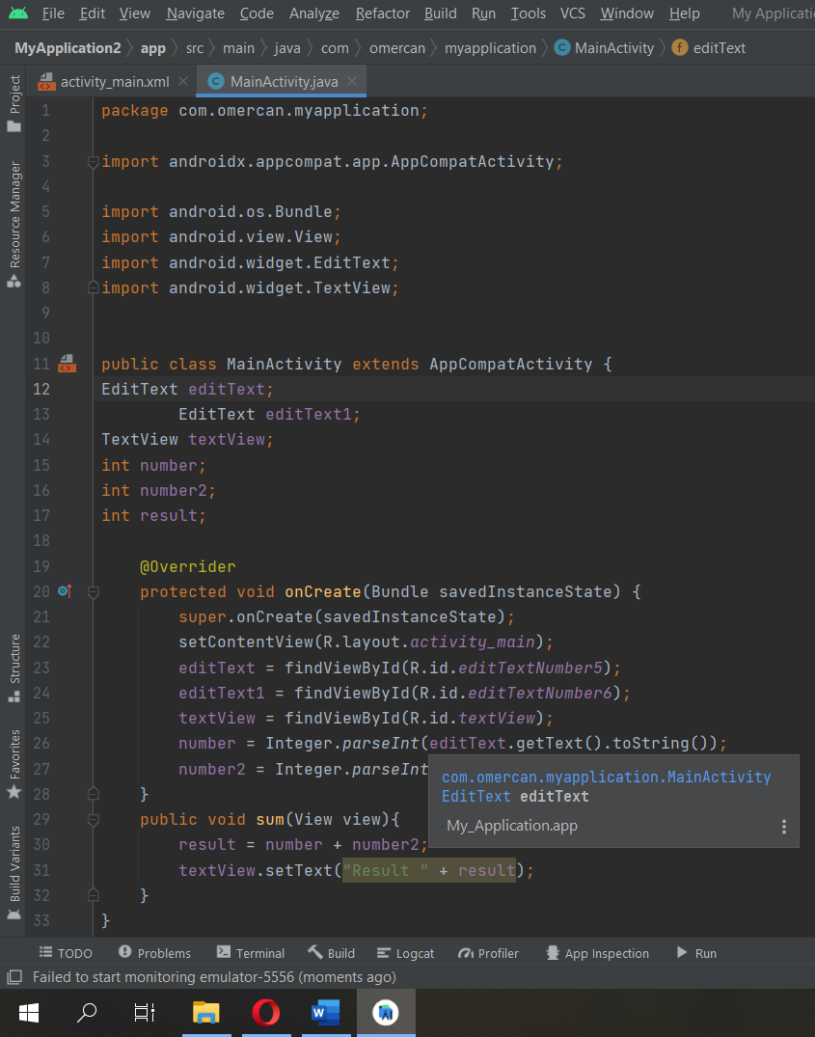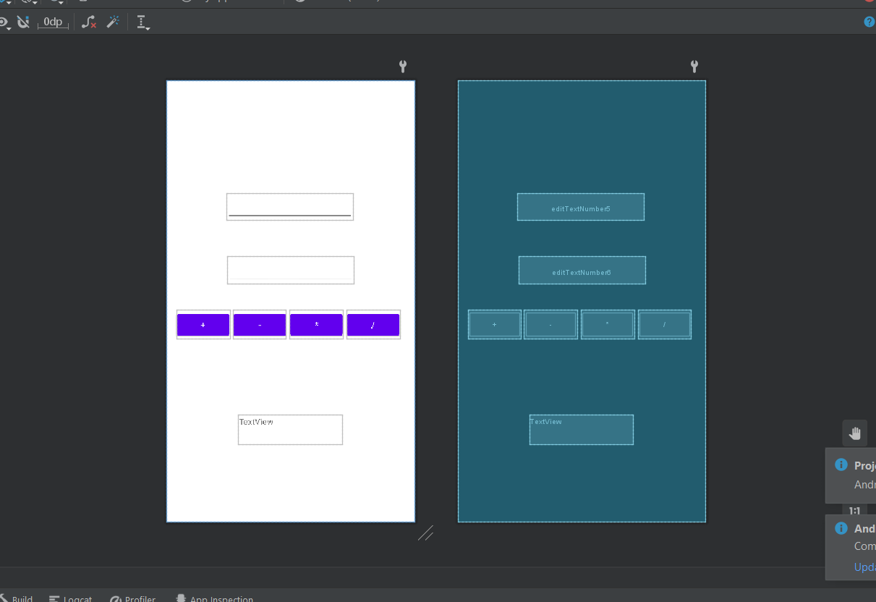

|  |  |
| --- | --- |
| Internship: How to describe to layout in Main Activty | Page No: 2 |

Today I made a small Project. That Project is simple calculator . Firstly I put 4 EditText , 1 Button and 1 TextView in layout. After that I decribe in main aktivity. Actually is so easy for me. Firstly I write in Actvity Main “EditText editText; “. After that I writed “editText = findViewById(R.id.editText);” That code will connect layout and Main Activity.Anyway, I finished that code. And I learned build simple program. That information provide to make a Currency Exchange app. These Pictures is my first Project.

# DAILY REPORT

|  |  |
| --- | --- |
| Internship:Off Day | Page No: 3 |

Today I’am so busy. Than I don’t progress udemy course.

# DAILY REPORT

|  |  |
| --- | --- |
| Internship: To research how to make currency conversion in Android Studio | Page No: 4 |

Today I fell ready for start my real Project. Than I research to how make currency conversion in Google. I find some github link and I examined that github link. Fristly,I learned the API,API most importante for me because I want to live app,so every currency will be current. Therefor I need a API and How to combine that API in my code. I looked my udemy corses and I found lesson about API.

# DAILY REPORT

|  |  |
| --- | --- |
| Internship: Retrofit, Cyrpto Money | Page No: 5 |

metin, bilgisayar, dizüstü, ekran içeren bir resim

Açıklama otomatik olarak oluşturuldu

Today I started again in my couse. I learned how get data on internet. Especially, It is so easy.Firstly I take a API adres for example  <https://api.nomics.com/> This adres provate to get API key. API key is special every developer. I registered this website, then they send me an email about API key. “14191978a0b0fe316101579251acca5303a22d55” this is my API key.If I write to <https://api.nomics.com/v1/markets?key=14191978a0b0fe316101579251acca5303a22d55> in search bar . I will Access to crypto data like the picure. After weak I will started real Project and I first purpose is I will make a layout in my Currency Conversion aplication.

# DAILY REPORT

|  |  |
| --- | --- |
| Internship: Make a Layout for Currency Converter | Page No: 6 |

Today I make Layout for my real Project. Firstly I put two spinner. These Spinner keep currncies For example EUR or USD. Than I put one edit text because user enter the yout amoung of currency. After that I put one text view, that shoe the result of convert to currency.And I added a button to do all this staff. I know it its looks so easy. But its work.

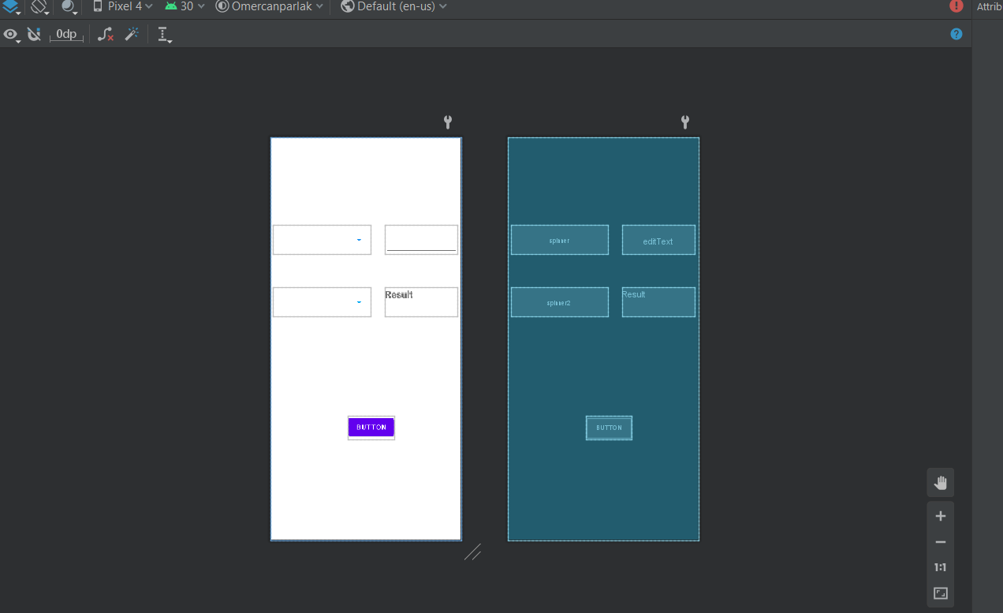

# DAILY REPORT

|  |  |
| --- | --- |
| Internship:I Make MainActivty Code | Page No: 7 |

Today I completed MainActivty Code. Firtly I decribe Layout. Than I built A new class and interface. These are provedes data retrival. But first I need explain retrofi. Retrofi is a class in Android Studio. İts progress to API Date and Show the wherever developer wants.

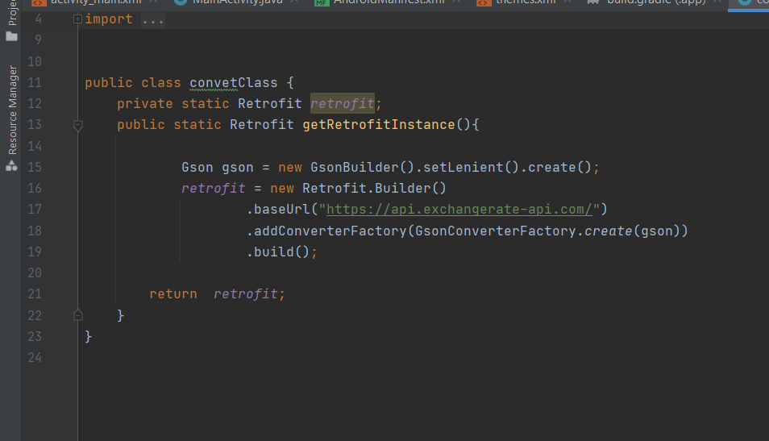

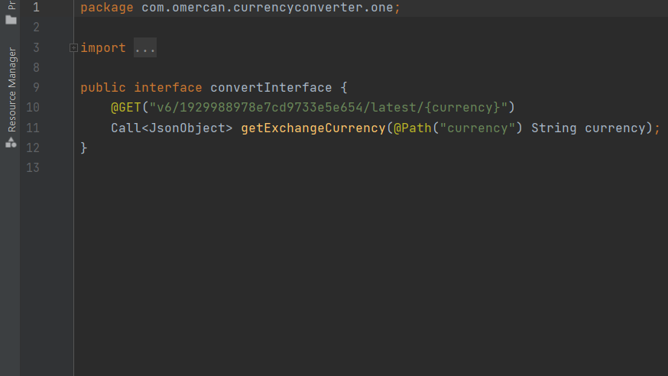This is my new class. And I define my API domein adrees.

This is my İnterface. This code connect to My class and This provides data retrival.

# DAILY REPORT

|  |  |
| --- | --- |
| Internship: I Encountered An Error | Page No: 8 |

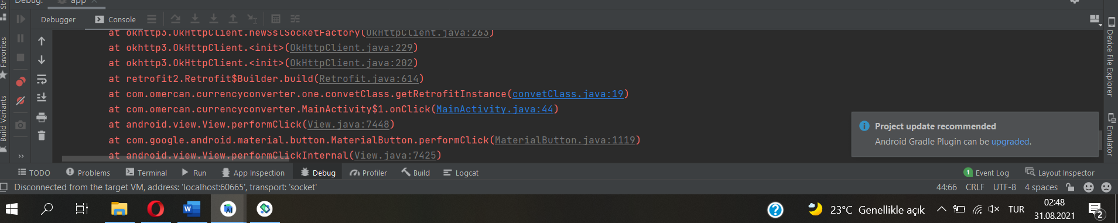

Today I encoubtered an Erorr and I check all code an layout. But I didn’t faund any mistake. Whit this I researched to Google how fix it this problem. Some website said greadel not current. Than I upgradeed my Gradel. But didn’t work. After, I cahnge my API adrees and API key but this is too didn’t work.I stopped to search and I get some rest.

# DAILY REPORT

|  |  |
| --- | --- |
| Internship:New Soliton | Page No: 9 |

Today I striven all night unfortunately I didn’t fixed thet erorr. Therefor I make new Project. That Project same to other Project. İts only difference,it isn’t retrival to data on internet. I will define to data manually.

# DAILY REPORT

|  |  |
| --- | --- |
| Internship: OFF Day | Page No: 10 |

Today I am so tired because of I striven fixed error last night. Therefot I want to rest.

# DAILY REPORT

|  |  |
| --- | --- |
| Internship: Make a projct again | Page No: 11 |

Today I started again my new Project. I made same layout because of this layout looks good for me. I foxed how to enter the data manualy. I chose base currency. İt’s EUR. İf EUR is 1 other currency respectively USD = 1.18 , GBP = 0.86 ,CAD =1.49 , CHF = 1.08 , TRY = 9.85. If I want to convert Usd to Try . 9.85/1.18 = 8,34 that is 1 usd equals to 8,34 try. Now I write the these code.Firstly I build String Array and I defined currency unit in this String Array. I build second array. This array is double array and I defined too amount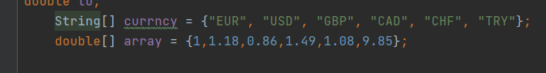 like this picure.

# DAILY REPORT

|  |  |
| --- | --- |
| Internship: Make ActivtyMain Body | Page No: 12 |

Today I made Activty Main Body. Fristly I defined editText , textView and Spinners.After, I provided to keep in spinner the currency unit. I used ArrayAdapter method. By this method defined String Array to spinner.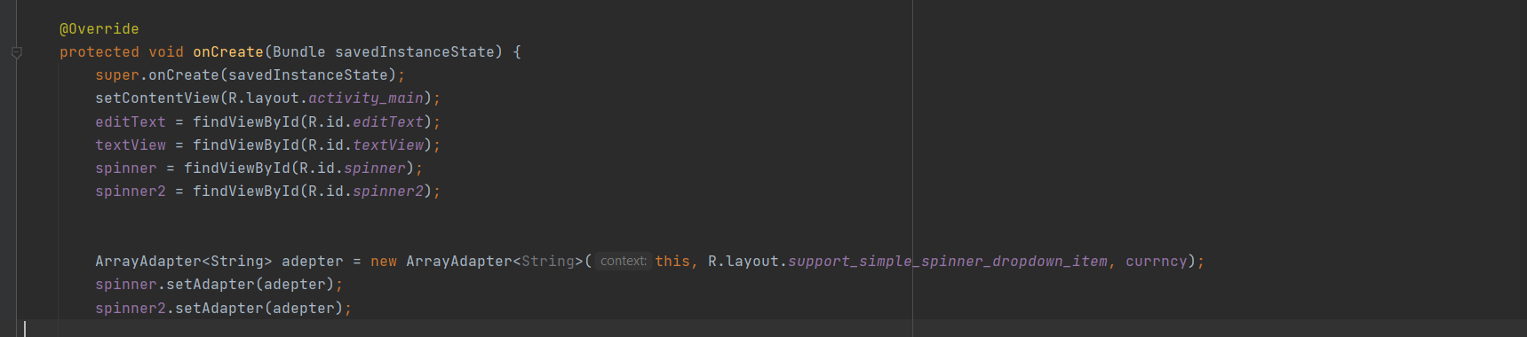

# DAILY REPORT

|  |  |
| --- | --- |
| Internship: Make Button Method | Page No: 13 |

Today I Made Button Method . I defined two double . These are among and price . Among is Number of entered by user. Price is among multiple convert.Conver is a anorher method. This method find a unit price. Last day I wrote about that. Anyway, Convert return the unit for button method. Last part is textView.setText(Stirng.valueOf(price)). This is Show the result for user.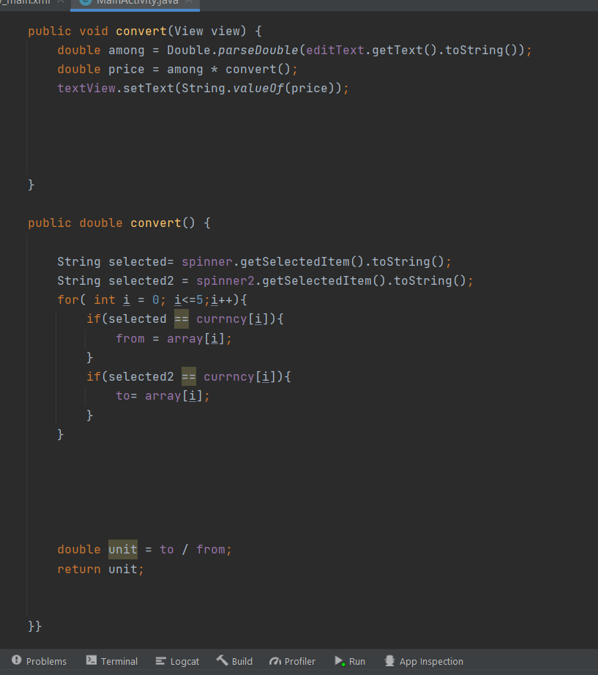

# DAILY REPORT

|  |  |
| --- | --- |
| Internship:Of DAY | Page No: 14 |

# DAILY REPORT

|  |  |
| --- | --- |
| Internship: OF DAY | Page No: 15 |

# DAILY REPORT

|  |  |
| --- | --- |
| Internship: Run To Program | Page No: 16 |

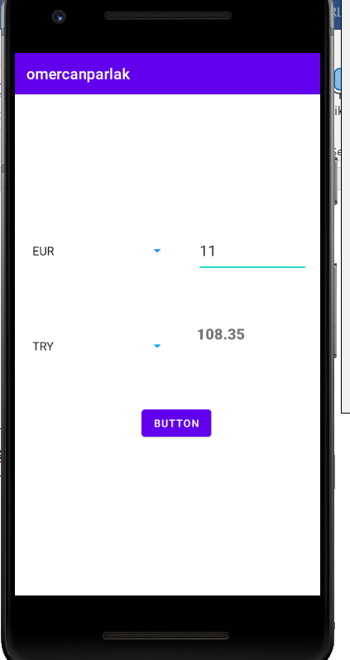

Today I run to progam and I didn’t saw any bug and error.Project interface looks this. And program worked every unit. I spend a lot of time and I so happy. It’s my first Project and I finised succesfuly.

# DAILY REPORT

|  |  |
| --- | --- |
| Internship: | Page No: 17 |

|  |  |  |  |  |  |  |  |  |  |  |  |  |  |  |  |  |  |  |  |  |  |  |  |  |  |  |  |  |  |  |  |  |  |  |
| --- | --- | --- | --- | --- | --- | --- | --- | --- | --- | --- | --- | --- | --- | --- | --- | --- | --- | --- | --- | --- | --- | --- | --- | --- | --- | --- | --- | --- | --- | --- | --- | --- | --- | --- |
|  |  |  |  |  |  |  |  |  |  |  |  |  |  |  |  |  |  |  |  |  |  |  |  |  |  |  |  |  |  |  |  |  |  |  |
|  |  |  |  |  |  |  |  |  |  |  |  |  |  |  |  |  |  |  |  |  |  |  |  |  |  |  |  |  |  |  |  |  |  |  |
|  |  |  |  |  |  |  |  |  |  |  |  |  |  |  |  |  |  |  |  |  |  |  |  |  |  |  |  |  |  |  |  |  |  |  |
|  |  |  |  |  |  |  |  |  |  |  |  |  |  |  |  |  |  |  |  |  |  |  |  |  |  |  |  |  |  |  |  |  |  |  |
|  |  |  |  |  |  |  |  |  |  |  |  |  |  |  |  |  |  |  |  |  |  |  |  |  |  |  |  |  |  |  |  |  |  |  |
|  |  |  |  |  |  |  |  |  |  |  |  |  |  |  |  |  |  |  |  |  |  |  |  |  |  |  |  |  |  |  |  |  |  |  |
|  |  |  |  |  |  |  |  |  |  |  |  |  |  |  |  |  |  |  |  |  |  |  |  |  |  |  |  |  |  |  |  |  |  |  |
|  |  |  |  |  |  |  |  |  |  |  |  |  |  |  |  |  |  |  |  |  |  |  |  |  |  |  |  |  |  |  |  |  |  |  |
|  |  |  |  |  |  |  |  |  |  |  |  |  |  |  |  |  |  |  |  |  |  |  |  |  |  |  |  |  |  |  |  |  |  |  |
|  |  |  |  |  |  |  |  |  |  |  |  |  |  |  |  |  |  |  |  |  |  |  |  |  |  |  |  |  |  |  |  |  |  |  |
|  |  |  |  |  |  |  |  |  |  |  |  |  |  |  |  |  |  |  |  |  |  |  |  |  |  |  |  |  |  |  |  |  |  |  |
|  |  |  |  |  |  |  |  |  |  |  |  |  |  |  |  |  |  |  |  |  |  |  |  |  |  |  |  |  |  |  |  |  |  |  |
|  |  |  |  |  |  |  |  |  |  |  |  |  |  |  |  |  |  |  |  |  |  |  |  |  |  |  |  |  |  |  |  |  |  |  |
|  |  |  |  |  |  |  |  |  |  |  |  |  |  |  |  |  |  |  |  |  |  |  |  |  |  |  |  |  |  |  |  |  |  |  |
|  |  |  |  |  |  |  |  |  |  |  |  |  |  |  |  |  |  |  |  |  |  |  |  |  |  |  |  |  |  |  |  |  |  |  |
|  |  |  |  |  |  |  |  |  |  |  |  |  |  |  |  |  |  |  |  |  |  |  |  |  |  |  |  |  |  |  |  |  |  |  |
|  |  |  |  |  |  |  |  |  |  |  |  |  |  |  |  |  |  |  |  |  |  |  |  |  |  |  |  |  |  |  |  |  |  |  |
|  |  |  |  |  |  |  |  |  |  |  |  |  |  |  |  |  |  |  |  |  |  |  |  |  |  |  |  |  |  |  |  |  |  |  |
|  |  |  |  |  |  |  |  |  |  |  |  |  |  |  |  |  |  |  |  |  |  |  |  |  |  |  |  |  |  |  |  |  |  |  |
|  |  |  |  |  |  |  |  |  |  |  |  |  |  |  |  |  |  |  |  |  |  |  |  |  |  |  |  |  |  |  |  |  |  |  |
|  |  |  |  |  |  |  |  |  |  |  |  |  |  |  |  |  |  |  |  |  |  |  |  |  |  |  |  |  |  |  |  |  |  |  |
|  |  |  |  |  |  |  |  |  |  |  |  |  |  |  |  |  |  |  |  |  |  |  |  |  |  |  |  |  |  |  |  |  |  |  |
|  |  |  |  |  |  |  |  |  |  |  |  |  |  |  |  |  |  |  |  |  |  |  |  |  |  |  |  |  |  |  |  |  |  |  |
|  |  |  |  |  |  |  |  |  |  |  |  |  |  |  |  |  |  |  |  |  |  |  |  |  |  |  |  |  |  |  |  |  |  |  |
|  |  |  |  |  |  |  |  |  |  |  |  |  |  |  |  |  |  |  |  |  |  |  |  |  |  |  |  |  |  |  |  |  |  |  |
|  |  |  |  |  |  |  |  |  |  |  |  |  |  |  |  |  |  |  |  |  |  |  |  |  |  |  |  |  |  |  |  |  |  |  |
|  |  |  |  |  |  |  |  |  |  |  |  |  |  |  |  |  |  |  |  |  |  |  |  |  |  |  |  |  |  |  |  |  |  |  |
|  |  |  |  |  |  |  |  |  |  |  |  |  |  |  |  |  |  |  |  |  |  |  |  |  |  |  |  |  |  |  |  |  |  |  |
|  |  |  |  |  |  |  |  |  |  |  |  |  |  |  |  |  |  |  |  |  |  |  |  |  |  |  |  |  |  |  |  |  |  |  |
|  |  |  |  |  |  |  |  |  |  |  |  |  |  |  |  |  |  |  |  |  |  |  |  |  |  |  |  |  |  |  |  |  |  |  |
|  |  |  |  |  |  |  |  |  |  |  |  |  |  |  |  |  |  |  |  |  |  |  |  |  |  |  |  |  |  |  |  |  |  |  |
|  |  |  |  |  |  |  |  |  |  |  |  |  |  |  |  |  |  |  |  |  |  |  |  |  |  |  |  |  |  |  |  |  |  |  |
|  |  |  |  |  |  |  |  |  |  |  |  |  |  |  |  |  |  |  |  |  |  |  |  |  |  |  |  |  |  |  |  |  |  |  |
|  |  |  |  |  |  |  |  |  |  |  |  |  |  |  |  |  |  |  |  |  |  |  |  |  |  |  |  |  |  |  |  |  |  |  |
|  |  |  |  |  |  |  |  |  |  |  |  |  |  |  |  |  |  |  |  |  |  |  |  |  |  |  |  |  |  |  |  |  |  |  |
|  |  |  |  |  |  |  |  |  |  |  |  |  |  |  |  |  |  |  |  |  |  |  |  |  |  |  |  |  |  |  |  |  |  |  |
|  |  |  |  |  |  |  |  |  |  |  |  |  |  |  |  |  |  |  |  |  |  |  |  |  |  |  |  |  |  |  |  |  |  |  |

# DAILY REPORT

|  |  |
| --- | --- |
| Internship: | Page No: 18 |

|  |  |  |  |  |  |  |  |  |  |  |  |  |  |  |  |  |  |  |  |  |  |  |  |  |  |  |  |  |  |  |  |  |  |  |
| --- | --- | --- | --- | --- | --- | --- | --- | --- | --- | --- | --- | --- | --- | --- | --- | --- | --- | --- | --- | --- | --- | --- | --- | --- | --- | --- | --- | --- | --- | --- | --- | --- | --- | --- |
|  |  |  |  |  |  |  |  |  |  |  |  |  |  |  |  |  |  |  |  |  |  |  |  |  |  |  |  |  |  |  |  |  |  |  |
|  |  |  |  |  |  |  |  |  |  |  |  |  |  |  |  |  |  |  |  |  |  |  |  |  |  |  |  |  |  |  |  |  |  |  |
|  |  |  |  |  |  |  |  |  |  |  |  |  |  |  |  |  |  |  |  |  |  |  |  |  |  |  |  |  |  |  |  |  |  |  |
|  |  |  |  |  |  |  |  |  |  |  |  |  |  |  |  |  |  |  |  |  |  |  |  |  |  |  |  |  |  |  |  |  |  |  |
|  |  |  |  |  |  |  |  |  |  |  |  |  |  |  |  |  |  |  |  |  |  |  |  |  |  |  |  |  |  |  |  |  |  |  |
|  |  |  |  |  |  |  |  |  |  |  |  |  |  |  |  |  |  |  |  |  |  |  |  |  |  |  |  |  |  |  |  |  |  |  |
|  |  |  |  |  |  |  |  |  |  |  |  |  |  |  |  |  |  |  |  |  |  |  |  |  |  |  |  |  |  |  |  |  |  |  |
|  |  |  |  |  |  |  |  |  |  |  |  |  |  |  |  |  |  |  |  |  |  |  |  |  |  |  |  |  |  |  |  |  |  |  |
|  |  |  |  |  |  |  |  |  |  |  |  |  |  |  |  |  |  |  |  |  |  |  |  |  |  |  |  |  |  |  |  |  |  |  |
|  |  |  |  |  |  |  |  |  |  |  |  |  |  |  |  |  |  |  |  |  |  |  |  |  |  |  |  |  |  |  |  |  |  |  |
|  |  |  |  |  |  |  |  |  |  |  |  |  |  |  |  |  |  |  |  |  |  |  |  |  |  |  |  |  |  |  |  |  |  |  |
|  |  |  |  |  |  |  |  |  |  |  |  |  |  |  |  |  |  |  |  |  |  |  |  |  |  |  |  |  |  |  |  |  |  |  |
|  |  |  |  |  |  |  |  |  |  |  |  |  |  |  |  |  |  |  |  |  |  |  |  |  |  |  |  |  |  |  |  |  |  |  |
|  |  |  |  |  |  |  |  |  |  |  |  |  |  |  |  |  |  |  |  |  |  |  |  |  |  |  |  |  |  |  |  |  |  |  |
|  |  |  |  |  |  |  |  |  |  |  |  |  |  |  |  |  |  |  |  |  |  |  |  |  |  |  |  |  |  |  |  |  |  |  |
|  |  |  |  |  |  |  |  |  |  |  |  |  |  |  |  |  |  |  |  |  |  |  |  |  |  |  |  |  |  |  |  |  |  |  |
|  |  |  |  |  |  |  |  |  |  |  |  |  |  |  |  |  |  |  |  |  |  |  |  |  |  |  |  |  |  |  |  |  |  |  |
|  |  |  |  |  |  |  |  |  |  |  |  |  |  |  |  |  |  |  |  |  |  |  |  |  |  |  |  |  |  |  |  |  |  |  |
|  |  |  |  |  |  |  |  |  |  |  |  |  |  |  |  |  |  |  |  |  |  |  |  |  |  |  |  |  |  |  |  |  |  |  |
|  |  |  |  |  |  |  |  |  |  |  |  |  |  |  |  |  |  |  |  |  |  |  |  |  |  |  |  |  |  |  |  |  |  |  |
|  |  |  |  |  |  |  |  |  |  |  |  |  |  |  |  |  |  |  |  |  |  |  |  |  |  |  |  |  |  |  |  |  |  |  |
|  |  |  |  |  |  |  |  |  |  |  |  |  |  |  |  |  |  |  |  |  |  |  |  |  |  |  |  |  |  |  |  |  |  |  |
|  |  |  |  |  |  |  |  |  |  |  |  |  |  |  |  |  |  |  |  |  |  |  |  |  |  |  |  |  |  |  |  |  |  |  |
|  |  |  |  |  |  |  |  |  |  |  |  |  |  |  |  |  |  |  |  |  |  |  |  |  |  |  |  |  |  |  |  |  |  |  |
|  |  |  |  |  |  |  |  |  |  |  |  |  |  |  |  |  |  |  |  |  |  |  |  |  |  |  |  |  |  |  |  |  |  |  |
|  |  |  |  |  |  |  |  |  |  |  |  |  |  |  |  |  |  |  |  |  |  |  |  |  |  |  |  |  |  |  |  |  |  |  |
|  |  |  |  |  |  |  |  |  |  |  |  |  |  |  |  |  |  |  |  |  |  |  |  |  |  |  |  |  |  |  |  |  |  |  |
|  |  |  |  |  |  |  |  |  |  |  |  |  |  |  |  |  |  |  |  |  |  |  |  |  |  |  |  |  |  |  |  |  |  |  |
|  |  |  |  |  |  |  |  |  |  |  |  |  |  |  |  |  |  |  |  |  |  |  |  |  |  |  |  |  |  |  |  |  |  |  |
|  |  |  |  |  |  |  |  |  |  |  |  |  |  |  |  |  |  |  |  |  |  |  |  |  |  |  |  |  |  |  |  |  |  |  |
|  |  |  |  |  |  |  |  |  |  |  |  |  |  |  |  |  |  |  |  |  |  |  |  |  |  |  |  |  |  |  |  |  |  |  |
|  |  |  |  |  |  |  |  |  |  |  |  |  |  |  |  |  |  |  |  |  |  |  |  |  |  |  |  |  |  |  |  |  |  |  |
|  |  |  |  |  |  |  |  |  |  |  |  |  |  |  |  |  |  |  |  |  |  |  |  |  |  |  |  |  |  |  |  |  |  |  |
|  |  |  |  |  |  |  |  |  |  |  |  |  |  |  |  |  |  |  |  |  |  |  |  |  |  |  |  |  |  |  |  |  |  |  |
|  |  |  |  |  |  |  |  |  |  |  |  |  |  |  |  |  |  |  |  |  |  |  |  |  |  |  |  |  |  |  |  |  |  |  |
|  |  |  |  |  |  |  |  |  |  |  |  |  |  |  |  |  |  |  |  |  |  |  |  |  |  |  |  |  |  |  |  |  |  |  |
|  |  |  |  |  |  |  |  |  |  |  |  |  |  |  |  |  |  |  |  |  |  |  |  |  |  |  |  |  |  |  |  |  |  |  |

# DAILY REPORT

|  |  |
| --- | --- |
| Internship: | Page No: 19 |

|  |  |  |  |  |  |  |  |  |  |  |  |  |  |  |  |  |  |  |  |  |  |  |  |  |  |  |  |  |  |  |  |  |  |  |
| --- | --- | --- | --- | --- | --- | --- | --- | --- | --- | --- | --- | --- | --- | --- | --- | --- | --- | --- | --- | --- | --- | --- | --- | --- | --- | --- | --- | --- | --- | --- | --- | --- | --- | --- |
|  |  |  |  |  |  |  |  |  |  |  |  |  |  |  |  |  |  |  |  |  |  |  |  |  |  |  |  |  |  |  |  |  |  |  |
|  |  |  |  |  |  |  |  |  |  |  |  |  |  |  |  |  |  |  |  |  |  |  |  |  |  |  |  |  |  |  |  |  |  |  |
|  |  |  |  |  |  |  |  |  |  |  |  |  |  |  |  |  |  |  |  |  |  |  |  |  |  |  |  |  |  |  |  |  |  |  |
|  |  |  |  |  |  |  |  |  |  |  |  |  |  |  |  |  |  |  |  |  |  |  |  |  |  |  |  |  |  |  |  |  |  |  |
|  |  |  |  |  |  |  |  |  |  |  |  |  |  |  |  |  |  |  |  |  |  |  |  |  |  |  |  |  |  |  |  |  |  |  |
|  |  |  |  |  |  |  |  |  |  |  |  |  |  |  |  |  |  |  |  |  |  |  |  |  |  |  |  |  |  |  |  |  |  |  |
|  |  |  |  |  |  |  |  |  |  |  |  |  |  |  |  |  |  |  |  |  |  |  |  |  |  |  |  |  |  |  |  |  |  |  |
|  |  |  |  |  |  |  |  |  |  |  |  |  |  |  |  |  |  |  |  |  |  |  |  |  |  |  |  |  |  |  |  |  |  |  |
|  |  |  |  |  |  |  |  |  |  |  |  |  |  |  |  |  |  |  |  |  |  |  |  |  |  |  |  |  |  |  |  |  |  |  |
|  |  |  |  |  |  |  |  |  |  |  |  |  |  |  |  |  |  |  |  |  |  |  |  |  |  |  |  |  |  |  |  |  |  |  |
|  |  |  |  |  |  |  |  |  |  |  |  |  |  |  |  |  |  |  |  |  |  |  |  |  |  |  |  |  |  |  |  |  |  |  |
|  |  |  |  |  |  |  |  |  |  |  |  |  |  |  |  |  |  |  |  |  |  |  |  |  |  |  |  |  |  |  |  |  |  |  |
|  |  |  |  |  |  |  |  |  |  |  |  |  |  |  |  |  |  |  |  |  |  |  |  |  |  |  |  |  |  |  |  |  |  |  |
|  |  |  |  |  |  |  |  |  |  |  |  |  |  |  |  |  |  |  |  |  |  |  |  |  |  |  |  |  |  |  |  |  |  |  |
|  |  |  |  |  |  |  |  |  |  |  |  |  |  |  |  |  |  |  |  |  |  |  |  |  |  |  |  |  |  |  |  |  |  |  |
|  |  |  |  |  |  |  |  |  |  |  |  |  |  |  |  |  |  |  |  |  |  |  |  |  |  |  |  |  |  |  |  |  |  |  |
|  |  |  |  |  |  |  |  |  |  |  |  |  |  |  |  |  |  |  |  |  |  |  |  |  |  |  |  |  |  |  |  |  |  |  |
|  |  |  |  |  |  |  |  |  |  |  |  |  |  |  |  |  |  |  |  |  |  |  |  |  |  |  |  |  |  |  |  |  |  |  |
|  |  |  |  |  |  |  |  |  |  |  |  |  |  |  |  |  |  |  |  |  |  |  |  |  |  |  |  |  |  |  |  |  |  |  |
|  |  |  |  |  |  |  |  |  |  |  |  |  |  |  |  |  |  |  |  |  |  |  |  |  |  |  |  |  |  |  |  |  |  |  |
|  |  |  |  |  |  |  |  |  |  |  |  |  |  |  |  |  |  |  |  |  |  |  |  |  |  |  |  |  |  |  |  |  |  |  |
|  |  |  |  |  |  |  |  |  |  |  |  |  |  |  |  |  |  |  |  |  |  |  |  |  |  |  |  |  |  |  |  |  |  |  |
|  |  |  |  |  |  |  |  |  |  |  |  |  |  |  |  |  |  |  |  |  |  |  |  |  |  |  |  |  |  |  |  |  |  |  |
|  |  |  |  |  |  |  |  |  |  |  |  |  |  |  |  |  |  |  |  |  |  |  |  |  |  |  |  |  |  |  |  |  |  |  |
|  |  |  |  |  |  |  |  |  |  |  |  |  |  |  |  |  |  |  |  |  |  |  |  |  |  |  |  |  |  |  |  |  |  |  |
|  |  |  |  |  |  |  |  |  |  |  |  |  |  |  |  |  |  |  |  |  |  |  |  |  |  |  |  |  |  |  |  |  |  |  |
|  |  |  |  |  |  |  |  |  |  |  |  |  |  |  |  |  |  |  |  |  |  |  |  |  |  |  |  |  |  |  |  |  |  |  |
|  |  |  |  |  |  |  |  |  |  |  |  |  |  |  |  |  |  |  |  |  |  |  |  |  |  |  |  |  |  |  |  |  |  |  |
|  |  |  |  |  |  |  |  |  |  |  |  |  |  |  |  |  |  |  |  |  |  |  |  |  |  |  |  |  |  |  |  |  |  |  |
|  |  |  |  |  |  |  |  |  |  |  |  |  |  |  |  |  |  |  |  |  |  |  |  |  |  |  |  |  |  |  |  |  |  |  |
|  |  |  |  |  |  |  |  |  |  |  |  |  |  |  |  |  |  |  |  |  |  |  |  |  |  |  |  |  |  |  |  |  |  |  |
|  |  |  |  |  |  |  |  |  |  |  |  |  |  |  |  |  |  |  |  |  |  |  |  |  |  |  |  |  |  |  |  |  |  |  |
|  |  |  |  |  |  |  |  |  |  |  |  |  |  |  |  |  |  |  |  |  |  |  |  |  |  |  |  |  |  |  |  |  |  |  |
|  |  |  |  |  |  |  |  |  |  |  |  |  |  |  |  |  |  |  |  |  |  |  |  |  |  |  |  |  |  |  |  |  |  |  |
|  |  |  |  |  |  |  |  |  |  |  |  |  |  |  |  |  |  |  |  |  |  |  |  |  |  |  |  |  |  |  |  |  |  |  |
|  |  |  |  |  |  |  |  |  |  |  |  |  |  |  |  |  |  |  |  |  |  |  |  |  |  |  |  |  |  |  |  |  |  |  |
|  |  |  |  |  |  |  |  |  |  |  |  |  |  |  |  |  |  |  |  |  |  |  |  |  |  |  |  |  |  |  |  |  |  |  |

# DAILY REPORT

|  |  |
| --- | --- |
| Internship: | Page No: 20 |

|  |  |  |  |  |  |  |  |  |  |  |  |  |  |  |  |  |  |  |  |  |  |  |  |  |  |  |  |  |  |  |  |  |  |  |
| --- | --- | --- | --- | --- | --- | --- | --- | --- | --- | --- | --- | --- | --- | --- | --- | --- | --- | --- | --- | --- | --- | --- | --- | --- | --- | --- | --- | --- | --- | --- | --- | --- | --- | --- |
|  |  |  |  |  |  |  |  |  |  |  |  |  |  |  |  |  |  |  |  |  |  |  |  |  |  |  |  |  |  |  |  |  |  |  |
|  |  |  |  |  |  |  |  |  |  |  |  |  |  |  |  |  |  |  |  |  |  |  |  |  |  |  |  |  |  |  |  |  |  |  |
|  |  |  |  |  |  |  |  |  |  |  |  |  |  |  |  |  |  |  |  |  |  |  |  |  |  |  |  |  |  |  |  |  |  |  |
|  |  |  |  |  |  |  |  |  |  |  |  |  |  |  |  |  |  |  |  |  |  |  |  |  |  |  |  |  |  |  |  |  |  |  |
|  |  |  |  |  |  |  |  |  |  |  |  |  |  |  |  |  |  |  |  |  |  |  |  |  |  |  |  |  |  |  |  |  |  |  |
|  |  |  |  |  |  |  |  |  |  |  |  |  |  |  |  |  |  |  |  |  |  |  |  |  |  |  |  |  |  |  |  |  |  |  |
|  |  |  |  |  |  |  |  |  |  |  |  |  |  |  |  |  |  |  |  |  |  |  |  |  |  |  |  |  |  |  |  |  |  |  |
|  |  |  |  |  |  |  |  |  |  |  |  |  |  |  |  |  |  |  |  |  |  |  |  |  |  |  |  |  |  |  |  |  |  |  |
|  |  |  |  |  |  |  |  |  |  |  |  |  |  |  |  |  |  |  |  |  |  |  |  |  |  |  |  |  |  |  |  |  |  |  |
|  |  |  |  |  |  |  |  |  |  |  |  |  |  |  |  |  |  |  |  |  |  |  |  |  |  |  |  |  |  |  |  |  |  |  |
|  |  |  |  |  |  |  |  |  |  |  |  |  |  |  |  |  |  |  |  |  |  |  |  |  |  |  |  |  |  |  |  |  |  |  |
|  |  |  |  |  |  |  |  |  |  |  |  |  |  |  |  |  |  |  |  |  |  |  |  |  |  |  |  |  |  |  |  |  |  |  |
|  |  |  |  |  |  |  |  |  |  |  |  |  |  |  |  |  |  |  |  |  |  |  |  |  |  |  |  |  |  |  |  |  |  |  |
|  |  |  |  |  |  |  |  |  |  |  |  |  |  |  |  |  |  |  |  |  |  |  |  |  |  |  |  |  |  |  |  |  |  |  |
|  |  |  |  |  |  |  |  |  |  |  |  |  |  |  |  |  |  |  |  |  |  |  |  |  |  |  |  |  |  |  |  |  |  |  |
|  |  |  |  |  |  |  |  |  |  |  |  |  |  |  |  |  |  |  |  |  |  |  |  |  |  |  |  |  |  |  |  |  |  |  |
|  |  |  |  |  |  |  |  |  |  |  |  |  |  |  |  |  |  |  |  |  |  |  |  |  |  |  |  |  |  |  |  |  |  |  |
|  |  |  |  |  |  |  |  |  |  |  |  |  |  |  |  |  |  |  |  |  |  |  |  |  |  |  |  |  |  |  |  |  |  |  |
|  |  |  |  |  |  |  |  |  |  |  |  |  |  |  |  |  |  |  |  |  |  |  |  |  |  |  |  |  |  |  |  |  |  |  |
|  |  |  |  |  |  |  |  |  |  |  |  |  |  |  |  |  |  |  |  |  |  |  |  |  |  |  |  |  |  |  |  |  |  |  |
|  |  |  |  |  |  |  |  |  |  |  |  |  |  |  |  |  |  |  |  |  |  |  |  |  |  |  |  |  |  |  |  |  |  |  |
|  |  |  |  |  |  |  |  |  |  |  |  |  |  |  |  |  |  |  |  |  |  |  |  |  |  |  |  |  |  |  |  |  |  |  |
|  |  |  |  |  |  |  |  |  |  |  |  |  |  |  |  |  |  |  |  |  |  |  |  |  |  |  |  |  |  |  |  |  |  |  |
|  |  |  |  |  |  |  |  |  |  |  |  |  |  |  |  |  |  |  |  |  |  |  |  |  |  |  |  |  |  |  |  |  |  |  |
|  |  |  |  |  |  |  |  |  |  |  |  |  |  |  |  |  |  |  |  |  |  |  |  |  |  |  |  |  |  |  |  |  |  |  |
|  |  |  |  |  |  |  |  |  |  |  |  |  |  |  |  |  |  |  |  |  |  |  |  |  |  |  |  |  |  |  |  |  |  |  |
|  |  |  |  |  |  |  |  |  |  |  |  |  |  |  |  |  |  |  |  |  |  |  |  |  |  |  |  |  |  |  |  |  |  |  |
|  |  |  |  |  |  |  |  |  |  |  |  |  |  |  |  |  |  |  |  |  |  |  |  |  |  |  |  |  |  |  |  |  |  |  |
|  |  |  |  |  |  |  |  |  |  |  |  |  |  |  |  |  |  |  |  |  |  |  |  |  |  |  |  |  |  |  |  |  |  |  |
|  |  |  |  |  |  |  |  |  |  |  |  |  |  |  |  |  |  |  |  |  |  |  |  |  |  |  |  |  |  |  |  |  |  |  |
|  |  |  |  |  |  |  |  |  |  |  |  |  |  |  |  |  |  |  |  |  |  |  |  |  |  |  |  |  |  |  |  |  |  |  |
|  |  |  |  |  |  |  |  |  |  |  |  |  |  |  |  |  |  |  |  |  |  |  |  |  |  |  |  |  |  |  |  |  |  |  |
|  |  |  |  |  |  |  |  |  |  |  |  |  |  |  |  |  |  |  |  |  |  |  |  |  |  |  |  |  |  |  |  |  |  |  |
|  |  |  |  |  |  |  |  |  |  |  |  |  |  |  |  |  |  |  |  |  |  |  |  |  |  |  |  |  |  |  |  |  |  |  |
|  |  |  |  |  |  |  |  |  |  |  |  |  |  |  |  |  |  |  |  |  |  |  |  |  |  |  |  |  |  |  |  |  |  |  |
|  |  |  |  |  |  |  |  |  |  |  |  |  |  |  |  |  |  |  |  |  |  |  |  |  |  |  |  |  |  |  |  |  |  |  |
|  |  |  |  |  |  |  |  |  |  |  |  |  |  |  |  |  |  |  |  |  |  |  |  |  |  |  |  |  |  |  |  |  |  |  |

**THE INTERNSHIP EVALUATION FORM OF THE INTERNSHIP COORDINATOR**

**Student**

Name Surname :

Department :

Grade :

StudentNumber :

Start/FinishDates :

|  |  |  |  |  |
| --- | --- | --- | --- | --- |
| **Evaluation Criteria** | **VeryGood** | **Good** | **Moderate** | **Insufficient** |
| Proper Use of the Internship Notebook |  |  |  |  |
| Effectiveness of Daily Reports |  |  |  |  |

# Evaluation of theInternship

|  |  |
| --- | --- |
| **SUCCESSFUL** |  |
| **UNSUCCESSFUL** |  |

**FacultyMember**

Name Surname :

Department :

Signature :

Date :

# InternshipCommission:

|  |  |
| --- | --- |
| **Title, Name Surname** | **Signature-Date** |
| **1-** |  |
| **2-** |  |
| **3-** |  |

**NOTE: This form will be filled in by the relevant internship coordinator after the notebook is delivered at the end of the internship.**